Year 2 Autumn 2 Art – Printing Roller and Ink
Key facts  - Paul Cezanne was a French painter.  - He lived from 1839 to 1906  - Cezanne’s often repetitive, exploratory brush strokes are highly characteristic and recognisable.  - Print making originated in China after paper was invented in AD 105  - Printmaking is an artistic process based on the transfer of an image from one surface to another  - Many fabrics and wallpapers are printed today  - Blending colours means creating an area between two colours where they gradually mix | 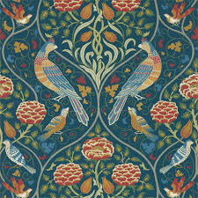  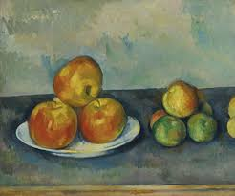  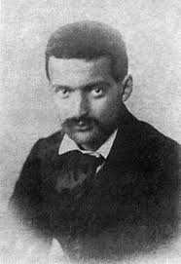  printed wallpaper  still life  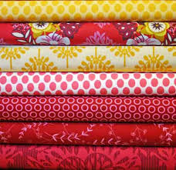  printed fabric  blending colours  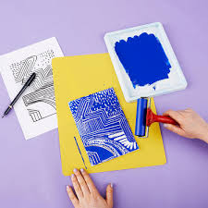  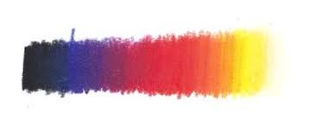  Paul Cezanne  roller printing
 | Vocabulary  - stencil  - portrait  - horizontal  - pressure  - patterning  - absorb  - saturated  - tessellated  - printing station  - blend  - transfer | Colour mixing  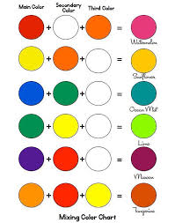  The primary colours red, blue and yellow can me mixed to make many new colours.

