Year 2 Autumn 1 Design and Technology – Sensational Salads
Key facts  - Salad are made up of either fruits or vegetables  - Sometimes fruits are added to a vegetable salad  - Salads can be a meal on their own, or be an accompaniment to a dish  - Salad helps you to eat five portions of fruit and vegetables a day  - Fruits and vegetables are rich in vitamins and minerals  - Fruits contain seeds  - Fruits develop from the flower of a plant  - Vegetables consist of roots, stems and leaves | 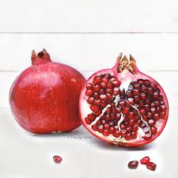  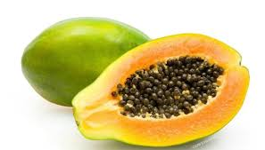  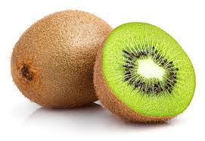  kiwi  pomegranate  papaya  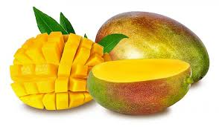  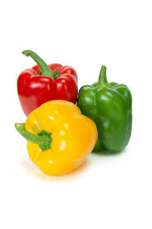  cabbage  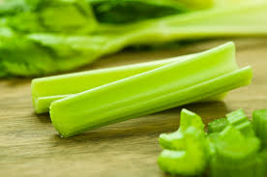  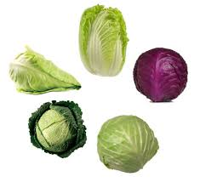  mango  peppers  celery
 | Vocabulary  - bush  - tree  - plant  - vine  - underground  - seed  - juicy  - cut  - chop  - flavour  - sweet  - sour | Types of salad  - fruit  - vegetable  - coleslaw  - wardorf  - beetroot  - potato  - carrot and sultana  Salads can be:  - tossed (mixed together)  - composed (carefully built)  - bound (mixed with mayonnaise)  - farinaceous (made with potatoes, pasta, quinoa, couscous etc)

