Year 1 Autumn 1 Humanities – History of Transport
Key facts  - People can travel by land, sea or air.  - People travel around London by bus, tube, train and tram.  - These are called public transport.  - People also travel by car or bike.  - In the past, horses used to pull buses and trams.  - Now buses and trams have engines.  - In the past, buses had open tops.  - Now buses have roofs.  - In the past, people bought paper tickets.  - Now we use Oyster cards. | 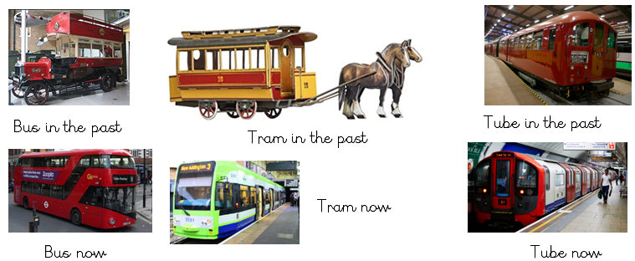
 | Vocabulary  - bus  - train  - tube  - tram  - horse  - old  - new  - past  - present  - road | Key dates/ timeline  - Before 1820 – horse drawn carriages  - 1820s - horse drawn trams and buses  - 1866- Denmark Hill Station opens  - 1895 - first motor bus  - 1863-Tube opens  - 1954- first Routemaster bus  - 2000 -Croydon Tramlink opens  - 2012 – new Routemaster bus

