Year 1 Autumn 1 Design and Technology - Playgrounds
Key facts  - Playgrounds are found in many towns, cities and villages  - Children and families go to the playground to socialise and play together  - Different equipment is put in the playground to develop different skills  - Playground equipment must be very strong  - It has to pass safety measures to ensure that there are no accidents  - Sometimes playgrounds include sandpits  - Skate parks are a form of playground for older children | 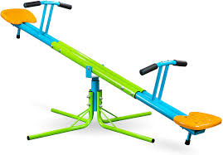  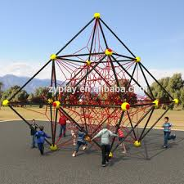  climbing frame  see saw  roundabout  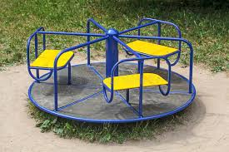  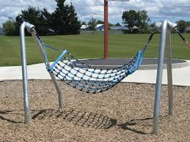  slide  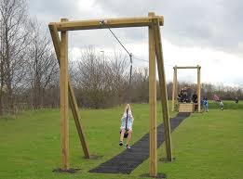  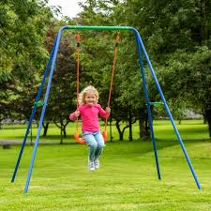  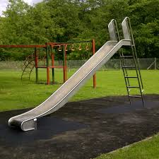  hammock swing  swing  zip wire
 | Vocabulary  - join  - nut  - bolt  - screw  - nail  - fix  - move  - hook  - turn  - rotate | Materials  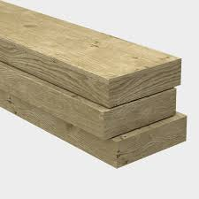  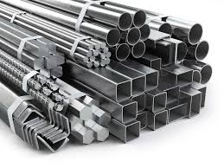  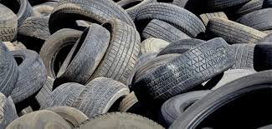  metal  plastic  rope  rubber  wood

