EYFS HOME LEARNING 27th April 2020
Reading: Every day, choose a book you have at home or a Bug Club book.
Monday  Draw your favourite character and write about them. What do they look like? | Tuesday  Write a list of new words from the story and find out what they mean. | Wednesday  Draw a story map.  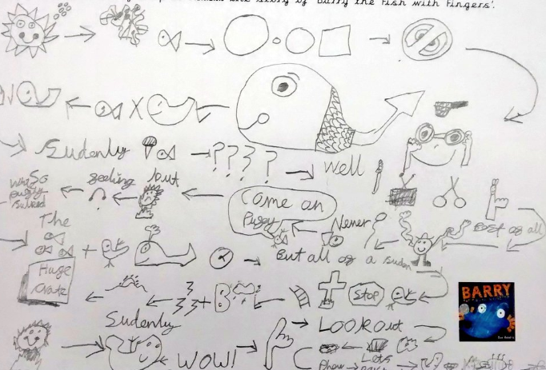 | Thursday  Draw and label your favourite part of the story. | Friday  Retell the story to an adult. Use some props, if you have any.
Phonics: Spend 10-15 minutes every day practising your phonics using games on Phonics play or www.ictgames.co.uk
Writing: Spend 10-15 minutes every day on a writing task.
Monday  Listen to the story ‘Willy the Wimp’.  https://www.youtube.com/watch?v=DY9z6BH682Y | Tuesday  Retell or preform the story to an adult/s. Use different voices or some props, if you have any. | Wednesday  Draw a picture and write about the different things Willy did to become braver. | Thursday  Draw a picture and write about when you have been brave. What did you do? You could start with, ‘I was brave when I…’ | Friday  Practice correctly writing the letters: r, n, m, h, p, b. Practice writing ‘tricky words’ all, they, my, like, so.
Maths: Spend 10-15 minutes every day on a maths task.
Monday  Number songs:  5 Speckled Frogs,  https://www.youtube.com/watch?v=VQTVrxj4l6o  10 Little Dinosaurs,  https://www.youtube.com/watch?v=TjmGTbNLj6Q  Let’s Count to 20,  https://www.youtube.com/watch?v=0VLxWIHRD4E | Tuesday  Make a repeating pattern using objects you find in your house. | Wednesday  Draw/colour a repeating pattern onto strips of paper. You can use 2, 3 or 4 different colours. | Thursday  Set up a simple shop and pay for items using money. Talk about the different sizes, colours and numbers you see. | Friday  Ask for your parent’s purse and sort the coins that you find to different sizes, colours and numbers.
Creative: Use paint, crayons, pens or any materials you have, to create an alien planet. What would it look like?
Understanding the World: Look outside your window and draw the living things that you can see in your environment.

