EYFS HOME LEARNING 27th April 2020
Reading: Every day, choose a book you have at home.
Monday  Draw your favourite character. | Tuesday  Pick out some new words from the story and talk about what they mean. | Wednesday  Draw a story map.  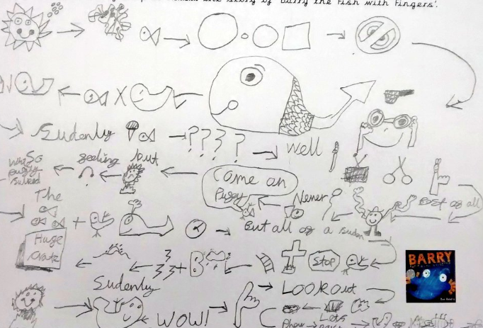 | Thursday  Draw your favourite part of the story and tell your adult why you liked that part. | Friday  Re-enact the story to an adult. Use some props, if you have any.
Phonics: Make different sounds with different parts of your body. Are the sounds the same or are they different?
Writing: spend 10-15 minutes every day.
Monday  Watch the short video about Firefighters. Have you seen a fire engine before?  https://www.youtube.com/watch?v=_aTbMjMJRS0 | Tuesday  Draw a picture of a firefighter or fire engine and ask your adult to write a sentence you say about it. | Wednesday  On a piece of paper use a red, orange, or yellow, pencil to write the letter ‘f’ as many times as you can. | Thursday  Practise writing the lower-case letters of your name correctly. Write the correct number for your age. | Friday  Say some words that begin with the sound ‘t’. Can you see anything at home in your house?
Maths: spend 10-15 minutes every day on a maths task
Monday  Number songs:  5 currant buns,  https://www.youtube.com/watch?v=c9bkEqA4x8o  5 speckled frogs,  https://www.youtube.com/watch?v=VQTVrxj4l6o  10 little dinosaurs,  https://www.youtube.com/watch?v=TjmGTbNLj6Q | Tuesday  Make a repeating pattern using objects you find in your house. | Wednesday  Draw/colour a repeating pattern onto strips of paper. You can use 2 or 3 different colours. | Thursday  Set up a simple shop and pay for items using money. Talk about the different sizes and numbers you see. | Friday  Ask for your parent’s purse and sort the coins that you find to different sizes and numbers.
Creative: Use paint, crayons, pens or any materials you have to make an alien planet. What would it look like?
Understanding the World: Look outside your window and draw the things that you can see in their environment.

