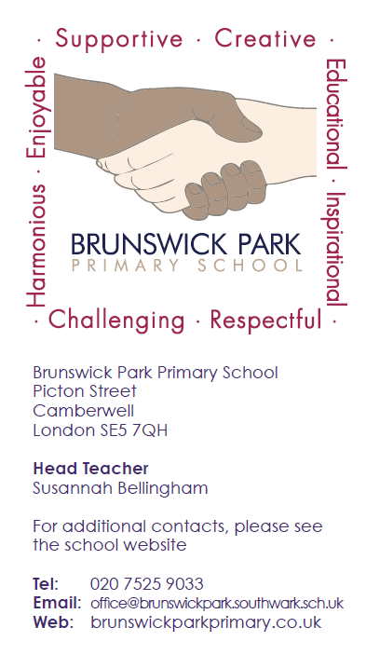

BRUNSWICK PARK PRIMARY SCHOOL

Contract Term: Permanent – MPS/UPS + optional TLR

Brunswick Park is unique, and is making great strides on its journey to Good. As a dynamic new KS2 teacher you will ensure that with the rest of the dedicated staff team, every child who attends learns well for living through respect, support and challenge. The school is Resource Based for pupils with ASC, and we are justly proud of our values based inclusive ethos that attracts parents and carers from far and wide. Situated only 20 minutes from Waterloo and the Elephant and Castle by bus and 10 minutes’ walk from Denmark Hill Train Station, Brunswick Park is host to a vibrant and diverse community. Our curriculum is enriched by residential visits, visitors, performances, sporting events and challenges, a wide variety of extra-curricular activities and by being at the heart of this wonderful city. Our children love learning and behave well. This is a fantastic, career-enhancing opportunity to inspire and lead.

Consistently good teaching is key to success, and we are looking for an excellent teacher who will impact positively on our children’s learning and well-being. If you are motivated by inspiring and nurturing young learners and want to take the next step in your career, we would love to hear from you. We are prepared to tailor the position to ensure we find the right candidate and can offer it with or without a TLR for Subject Leadership depending on the experience and interests of the applicant. We can be flexible regarding Year Group, though Upper KS2 would be an advantage.

We wish to appoint a consummate professional who:
- Makes learning fun, inclusive and engaging;
- Has a track record of raising achievement;
- Demonstrates initiative and can inspire, enthuse and lead others;
- Is a warm, engaging, effective communicator who will develop strong relationships with children, parents and the wider community;
- Is aspirational and committed to career development.

We offer:
- A vibrant, friendly, positive and enthusiastic learning community where everyone’s successes are celebrated;
- An inclusive, values based ethos committed to nurturing and developing the potential of every child;
- A supportive and stimulating environment where children are well behaved and keen to learn;
- A committed, motivated and reflective staff team including HLTAs, a Specialist Accredited Practitioner, a learning mentor and a team of therapists to support children’s emotional well-being;
- A strong desire for continued improvement and further development;
- Excellent professional and career development opportunities including gaining qualifications in Middle and Senior Leadership;
- The chance to work in a school like no other, where career-enhancing opportunities to broaden and develop skills and experience abound.
To find out more about this amazing opportunity, a visit is essential. To organise one at a mutually convenient time during the school day, please telephone our staff in the School Office or the Head Teacher directly on 020 7525 9033, or email Dena Dada at businessmanager@brunswickpark.southwark.sch.uk.
To obtain an application pack please email Dena Dada at businessmanager@brunswickpark.southwark.sch.uk, download one from our website www.brunswickparkprimary.co.uk or telephone the school on 020 7525 9033.
Skype interviews and lesson observations are available for international candidates.
Brunswick Park Primary School is committed to safeguarding and promoting the welfare of children and young people and expects all staff and volunteers to share this commitment. All appointments are subject to an Enhanced DBS Check, medical clearances and references.
Closing date for applications: We recruit on a rolling basis for this role

Learning for living through respect, support and challenge

